

ENM TUTORIALS

Browsing the eNM ontology with BioPortal, AberOWL and Protégé
license: CC-BY
RELEASE DATE: | 26-02-2016
USE: | Browsing the eNM ontology with BioPortal, AberOWL and Protégé
VERSION: | V.1.0.
MAIN AUTHOR: | Linda Rieswijk
PARTNER: | UM
CONTACT DETAILS: | linda.rieswijk@maastrichtuniversity.nl, friederike.ehrhart@maastrichtuniversity.nl, egon.willighagen@maastrichtuniversity.nl +31(0)43-38 82913
AUTHORS: | Linda Rieswijk, Friederike Ehrhart and Egon Willighagen

TABLE OF CONTENTS
1. INTRODUCTION
1.1 ABSTRACT
2. APPLICATION DETAILS
2. Tutorial for usage of the eNanoMapper Ontology for mapping terms
2.1. eNM ontology within Bioportal
2.2. eNM ontology within AberOWL
2.3. Open and browse the eNM ontology within Protégé
2.4. Follow-up procedure if term is not present in the eNM ontology
4. ACKNOWLEDGMENTS
5. REFERENCES
6. KEYWORDS

1. INTRODUCTION

ABSTRACT

The field of engineered nanomaterials is exponentially growing as well as the demand to assure the safe use of this type of materials. Nanomaterials are defined as being materials with at least one external dimension in the size range from approximately 1-100 nm. Nanoparticles are objects with all three external dimensions at the nanoscale. Engineered nanomaterials can be used within a numerous amount of application such as:

- In the design of pharmaceuticals specifically targeting organs or cells in the body such as cancer cells which also enhances the effectiveness of therapies.
- To make materials such as cloth or cement stronger and lighter.
- Use in electronics, as environmental remediation or clean-up to bind with and neutralize toxins, for their anti-bacterial function in cosmetics etc.

The primary objective of WP2 within the FP7 EU-funded eNanoMapper (eNM) project is to develop and disseminate a comprehensive ontology for the nanosafety domain, encompassing nanomaterials and all information relating to their characterization, as well as information describing relevant experimental paradigms, biological interactions, safety indications and experimental paradigms.

The current version of the eNanoMapper ontology^{1,2,3} is based on the re-usage of 18 existing ontologies (e.g. NanoParticle Ontology, BioAssay Ontology, Experimental Factor Ontology) (full details can be found in reference [1]) together with specialized engineered nanomaterials and nanotechnology vocabularies and definitions, which have been described by several national and international standardization committees (e.g. International Organization for Standardization, Joint Research Centre).

The re-used ontologies (OWL file) were made slimmer⁴, if necessary modified using the free, open-source ontology editor Protégé⁵ and new terms were added using the Issue Tracker within GitHub^{6,7,8}.

The eNM ontology might be accessed through three different ways, namely online via BioPortal^{2,9} and AberOWL^{3,10} or locally using the open-source Protégé⁵ software. This tutorial focusses on browsing through the eNM ontology when one would be interested in finding a Unique Resource Identifier (URI) for mapping a term originating from for example a database schema. Using URIs for database schemas will facilitate the harmonization of data originating from different sources and will make them more comparable.

In order to generate an ontology for engineered nanomaterials which is covering all domains also instructions are provided within this tutorial on which steps should be taken when a term is not present within the eNM ontology.

2. APPLICATION DETAILS

2. Tutorial for usage of the eNanoMapper Ontology for mapping terms

There are three options for searching URIs for terms originating from for example a database schema within the eNM ontology.

2.1. eNM ontology within BioPortal
        - Go to the ENM ontology within BioPortal.
          - HTTP://BIOPORTAL.BIOONTOLOGY.ORG/ONTOLOGIES/ENM
        - If you click on “classes” you will find the hierarchical ontological tree.
        - By clicking on “entity” all the sub- and head classes will be provided.
        - In the box of “Jump To:” a particular term might be searched within the ontology.
        - In this example we are interested in “zeta potential”.
        - Suggestions for possible URIs will be given which are present within the eNM ontology.
        - Click on the term you are interested in (in this case “zeta potential”).
        - Details will be provided on the term and the position of the term in the hierarchical ontological tree will be visualized (see Figure 1).

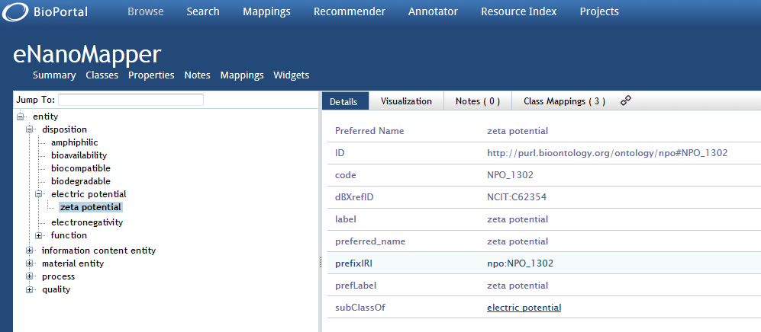

Figure 1: Browsing the eNM ontology within BioPortal.

2.2. eNM ontology within AberOWL
        - Go to the ENM ontology within AberOWL.
          - HTTP://ABER-OWL.NET/ONTOLOGY/ENM
        - On the left you will find an interactive view of the hierarchical ontological tree.
        - If you click on “entity” the tree will be unfolded thereby revealing the sub- and head classes of the ontology.
        - Above the “entity” field you will find a search box in which terms may be typed.
        - In this case we are interested in finding “zeta potential”.
        - Suggestions will be given for potential URIs which are present in the eNM ontology.
        - If you click on one of the suggested URIs the hierarchical ontological tree will fold out.
        - On the right the following information is given for this particular URI within the eNM ontology, for example for “zeta potential” (See Figure 2).

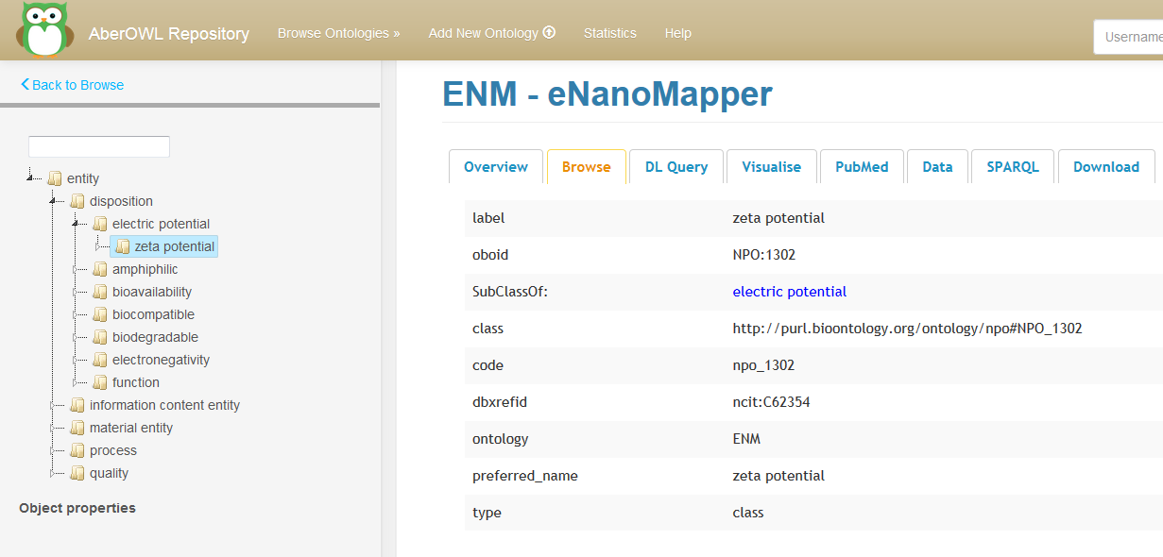Figure 2: Browsing the eNM ontology using AberOWL.

2.3. Open and browse the eNM ontology within Protégé
        - Protege can be downloaded from this page:
          - HTTP://PROTEGE.STANFORD.EDU/
        - Download the chosen ontology as .owl file from BioPortal (in this case the eNM ontology → See Figure 3).
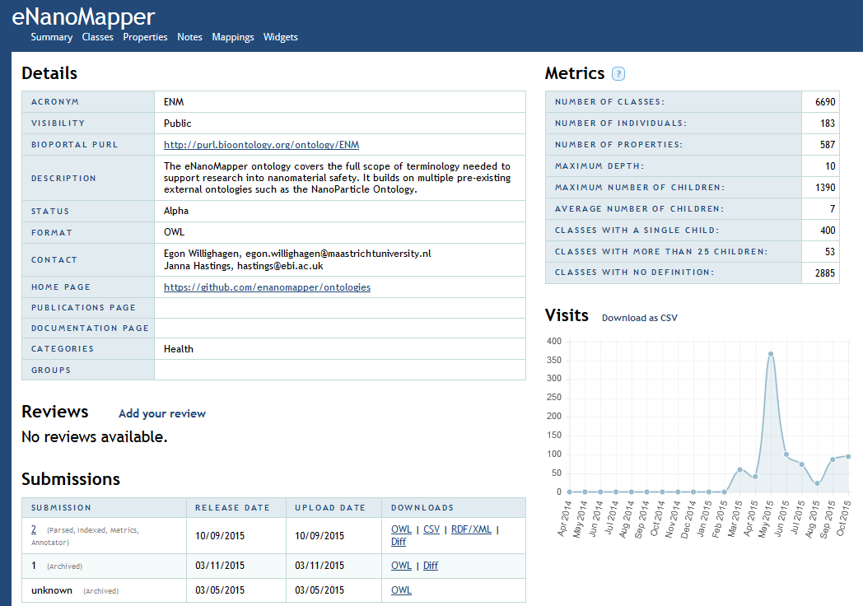

Figure 3: The OWL file from the eNM ontology on BioPortal.

        - Open Protégé and go to “file” “open” and select the downloaded .owl file - alternatively, “open from URL” and enter the URL.
        - Open the tab “entities” to get to the terms.
        - In this case we are interested in finding “amphiphilic”.
        - In class annotations and class usage you will find the detailed information: label, code, preferred name, synonym which can be edited, deleted or annotated (See Figure 4).
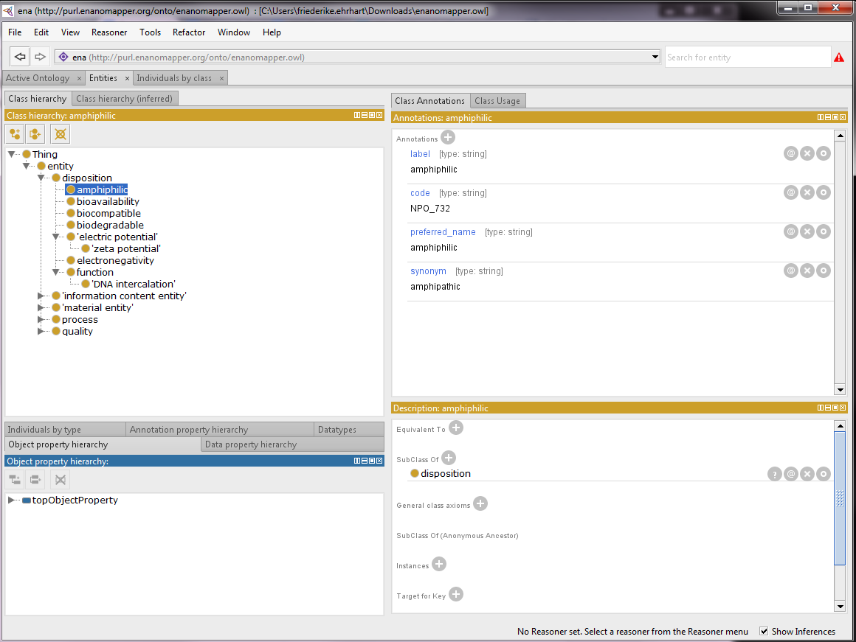
Figure 4: Browsing the eNM ontology in Protégé.

2.4. Follow-up procedure if term is not present in the eNM ontology
        - If the term is not present within the eNM Ontology it needs to be searched within one of the other existing ontologies.
        - At the moment the following external ontology sources are used within the creation of the eNM ontology (total of 6690 classes) (See Figure 5 and 6).
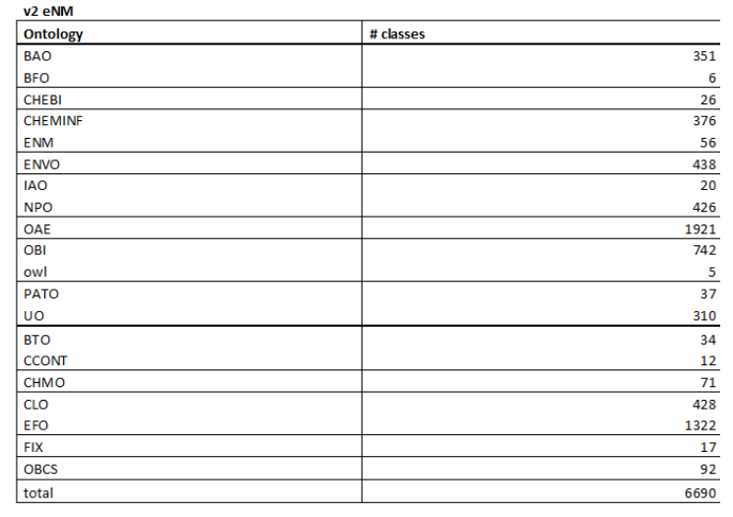

Figure 5: Number of used classes present within the eNM ontology and its respective originating external ontologies.

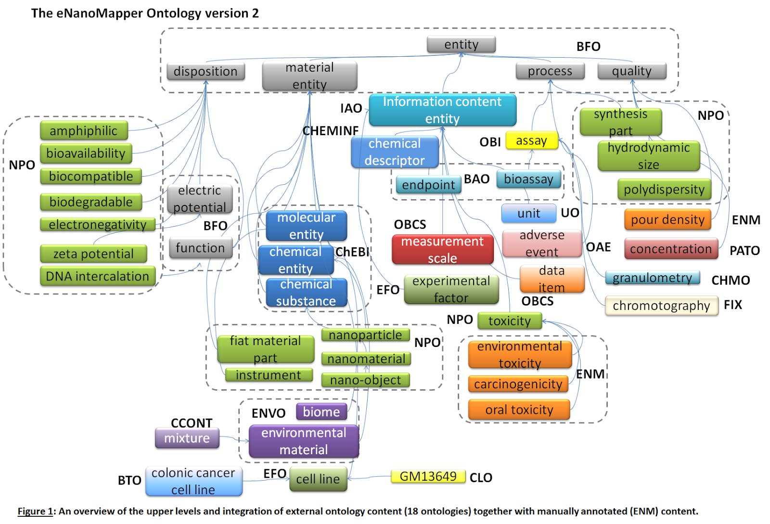

Figure 6: An overview of the upper levels and integration of external ontology content (18 ontologies) together with manually annotated (ENM) content.
        - Preferably the term should there be searched in one of these ontology sources.
          - In BioPortal you can do this as follows:
            - Go to “Search” in the toolbar.
            - Type in your term that you want to find an URI for.
            - Look at the suggestions given.
            - Take the URI which is originating from one of the above ontologies.
            - Also keep in mind the structure and position of the URI in the ontological tree.
            - Copy the full URI, label and prefix URI to for example an excel File.
          - In AberOWL this can be done as follows:
            - Go the home page of AberOWL.
            - Type in your term that you want to find an URI for.
            - Look at the suggestions given.
            - Take the URI which is originating from one of the above ontologies.
            - Also keep in mind the structure and position of the URI in the ontological tree.
            - Copy the full URI, label and prefix URI to for example an excel File.

        - For the follow-up there are two options:
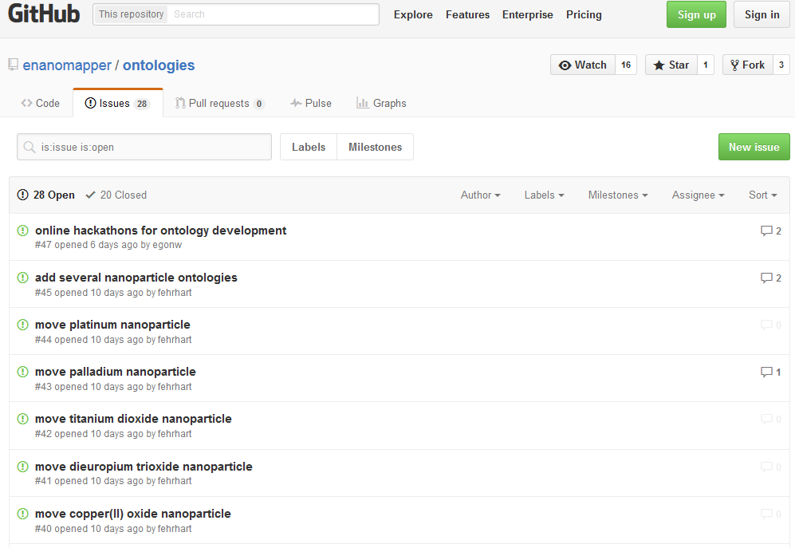
          - Request an addition of the URI to the eNM ontology via the Issue Tracker available on https://github.com/enanomapper/ontologies (“Issues” on the right side of the screen) (See Figure 7).
Figure 7: The Issue Tracker of the eNM ontology within GitHub.

          - Create a patch for the “slimmer” version of the eNM ontology which will be loaded together with the other included slimmed versions of the available ontologies (note: a slimmed version of the ontology includes only those URIs which are included within the eNM ontology; this is done since a full inclusion of all respective ontologies will be create a very extensive and aspecific ontology). Available at https://github.com/enanomapper/slimmer/tree/master/src/main/resources (see Figure 8).

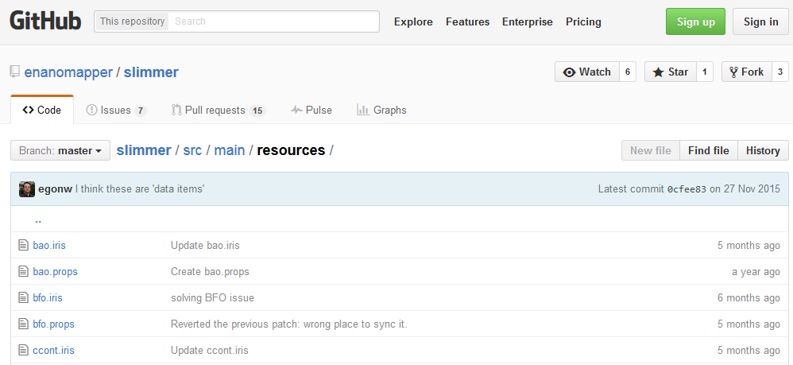

Figure 8: The “slimmed” versions of the used external ontologies for the eNM ontology.
          - If the URI is not present in one of the preferred ontology sources a correct additional ontology source should be chosen.
          - Once this has been done the follow-up options may be applied.

4. ACKNOWLEDGMENTS
We would like to express our gratitude for using the open-access applications of Bioportal, AberOWL and Protégé.

The eNanoMapper project is funded by the European Union's Seventh Framework Program for research, echnological development and demonstration (FP7-NMP-2013-SMALL-7) under grant agreement no. 604134.

5. REFERENCES
- Hastings, J., Jeliazkova, N., Owen, G., Tsiliki, G., Munteanu, C.R., Steinbeck, C., and Willighagen, E. (2015) eNanoMapper: harnessing ontologies to enable data integration for nanomaterial risk assessment. Journal of Biomedical Semantics, 6, 10. (doi:10.1186/s13326-015-0005-5).
- The eNM ontology in BioPortal (http://bioportal.bioontology.org/ontologies/ENM);
- The eNM ontology in AberOWL (http://aber-owl.net/ontology/enm).
- Slimmer version of external re-used ontologies present in eNM ontology within GitHub (https://github.com/enanomapper/slimmer).
- Open-source ontology editor Protégé (http://protege.stanford.edu/)
- The eNM ontology OWL within GitHub (https://github.com/enanomapper/ontologies).
- eNM Issue Tracker within GitHub (https://github.com/enanomapper/ontologies/issues).
- eNM Pull Requests within GitHub (https://github.com/enanomapper/slimmer/pulls).
- Whetzel, P.L., Noy, N.F., Shah, N.H., Alexander, P.R., Nyulas, C., Tudorache, T., and Musen, M.A. (2011) BioPortal: enhanced functionality via new Web services from the National Center for Biomedical Ontology to access and use ontologies in software applications. Nucleic Acids Res, 39, W541-545 (doi: 10.1093/nar/gkr469).
- Hoehndorf, R., Slater, L., Schofield, P.N., and Gkoutos, G.V. (2015) Aber-OWL: a framework for ontology-based data access in biology. BMC Bioinformatics, 16, 1-9 (doi: 10.1186/s12859-015-0456-9).

6. KEYWORDS
Engineered nanomaterials, ontology, Unique Resource Identifier.

